

A Project

Report On

**HOSPITAL MANAGEMENT SYSTEM**

**By**

**SUPRIYA K L**

**MCA**

**Batch:** 2021 – 6308

**Center: Bangalore**

Under the Guidance of,

**Jayanth V.**

**Technical Trainer**

**EduBridge**

(School of coding)

**Introduction:**

Our Project explains about the Hospita Management System.This project mainly explains appointment booking by inserting patient’s and doctor’s record . Also, the system displays all the available details of patient ,and doctors with their respective names,contact information,address,date and time.In addition,the system lists out all the available appointments which include doctor’s and patient’s names with their date and time respectively.

**Modules:-**

* Admin Module

* Docter Module

* Patient Module

I have developed this Application in **Python,Django and Sqlite3.** It’s a web-based projects so I have used **HTML, CSS, JavaScript.**

The main feature of the project is to easier to take appointment. You can access this website from anywhere and everywhere.

In Admin module, admin can register,view,approve,reject,delete doctor and also admin can admit,view,approve,reject,discharge patient.

In Doctor module, doctor’s can apply for job in hospital.Then login

They can only view their patient details assigned to that doctor by admit and they can view their dischared patient list and their Appointments,booked by admin and they can also delete their Appointment,when doctor attended their appointment.

In Patient module,Create account for admit in hospital.Then Login and view assigned doctor’s details and they can view their booked appointment status and book appointments and they can view download invoice pdf.

**Requirements:**

**Front end:** HTML, CSS, JavaScript, Bootstrap, Hibernate.

**Back end:Sqlite3**

**Browser:** Best result on Google Chrome

**Operating System:**  Window 10.

**ScrenShots:**

**Home Page:**

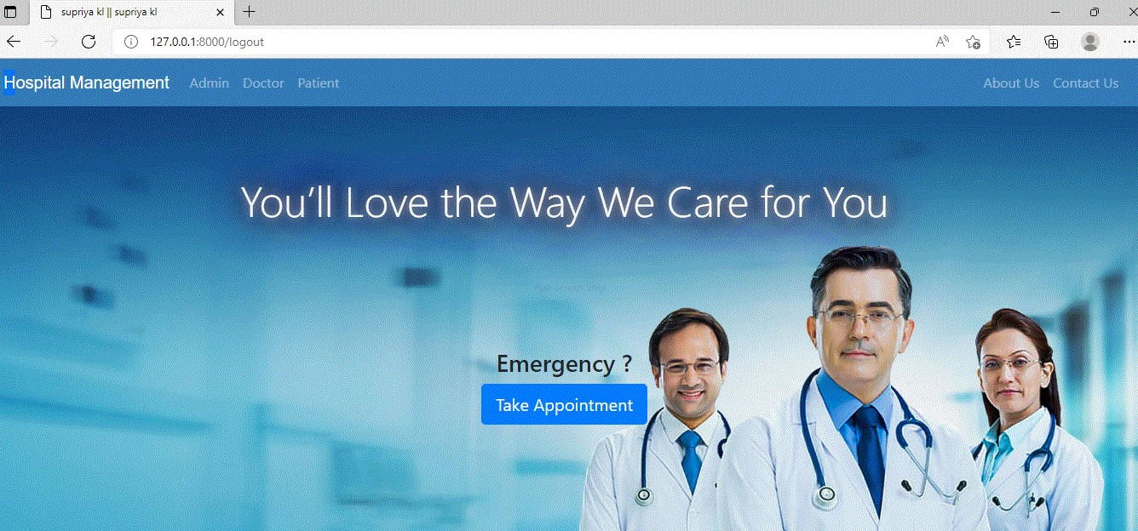

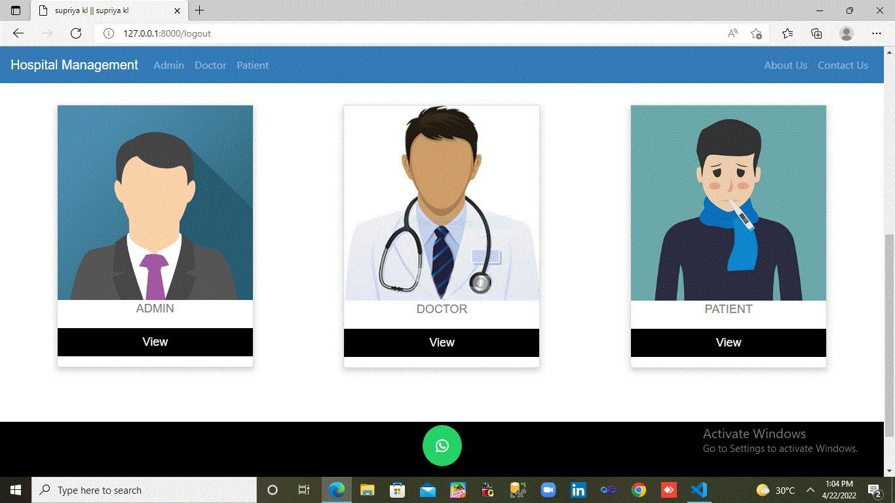

**Admin Dashboard:**

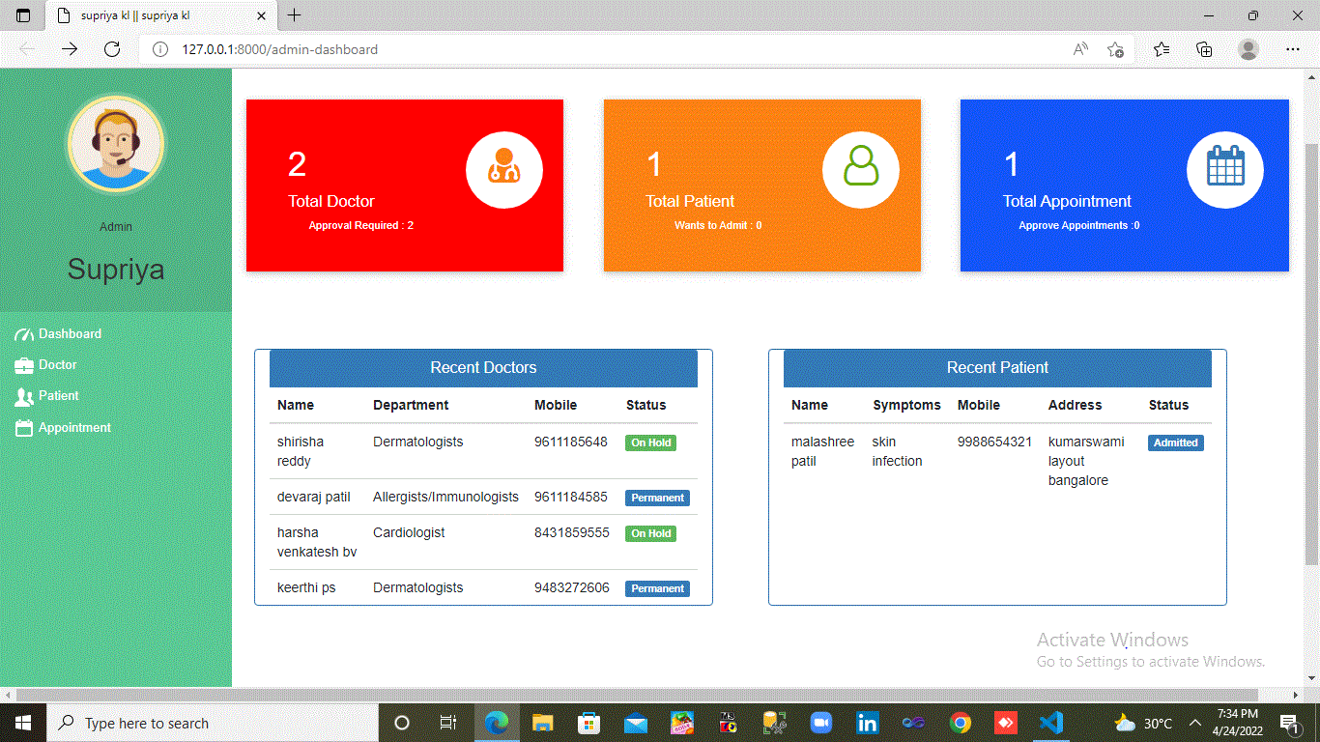

**Invoice:**

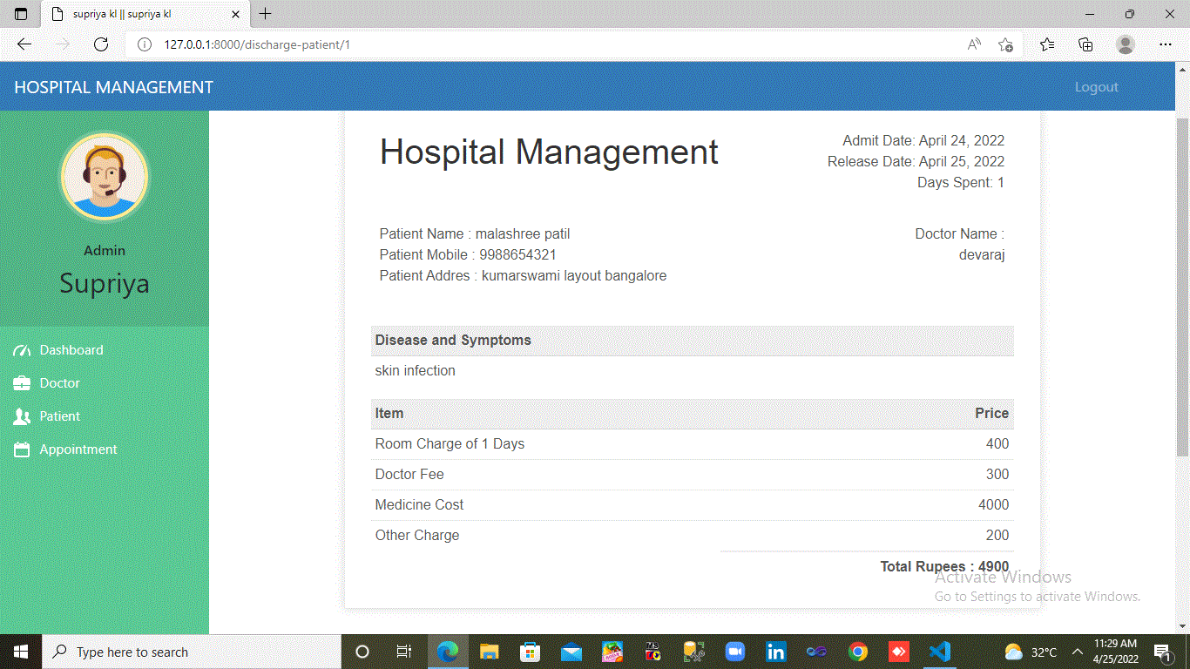

**Admin Login Page:**

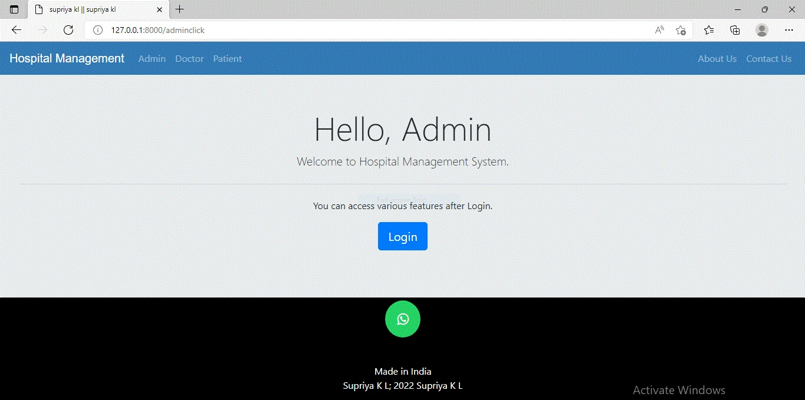

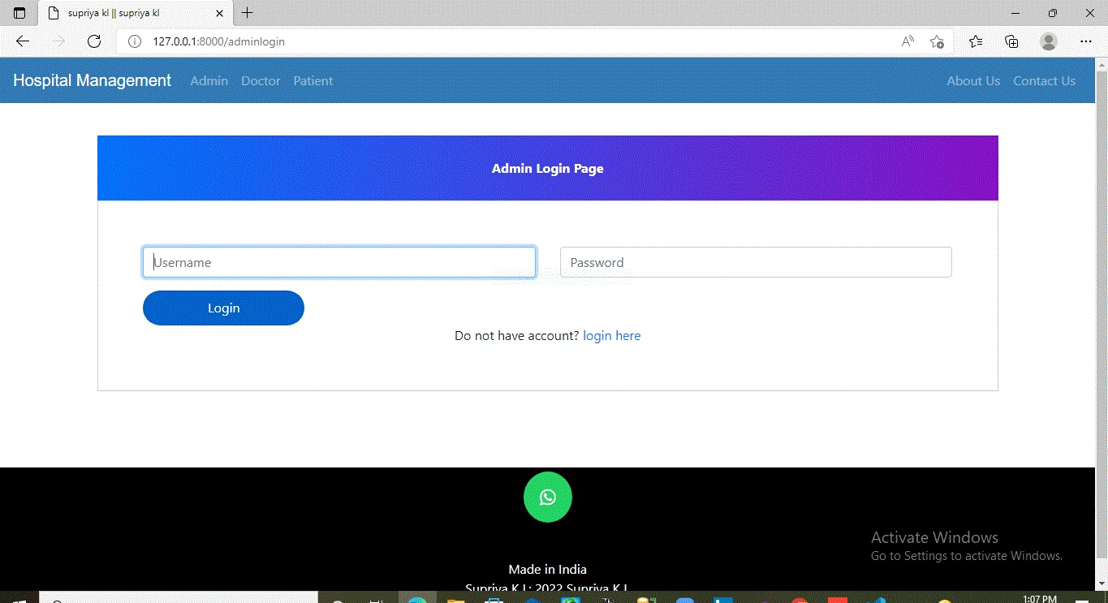

**Doctor Login Page:**

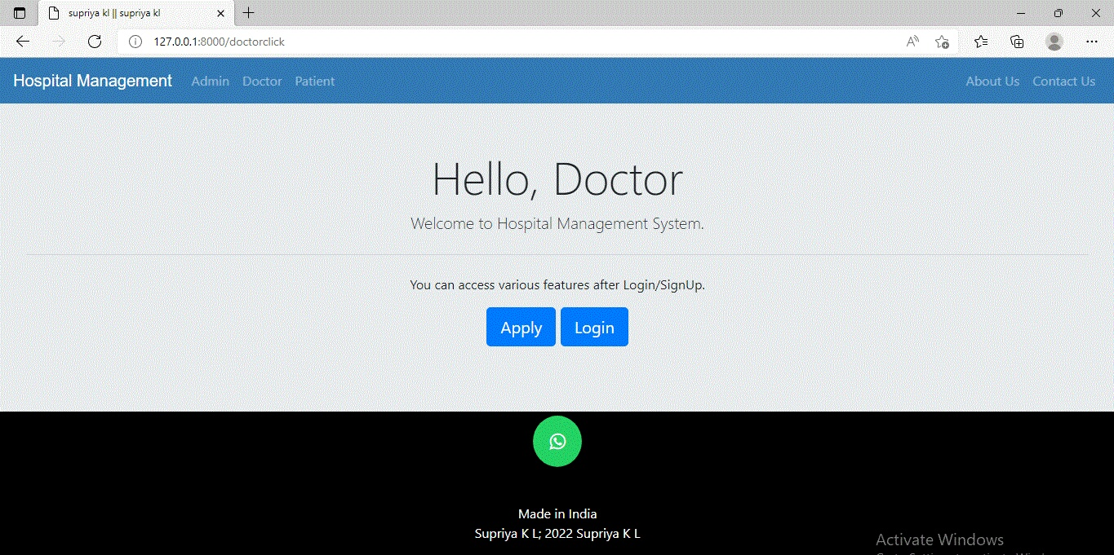

**Doctor list:**

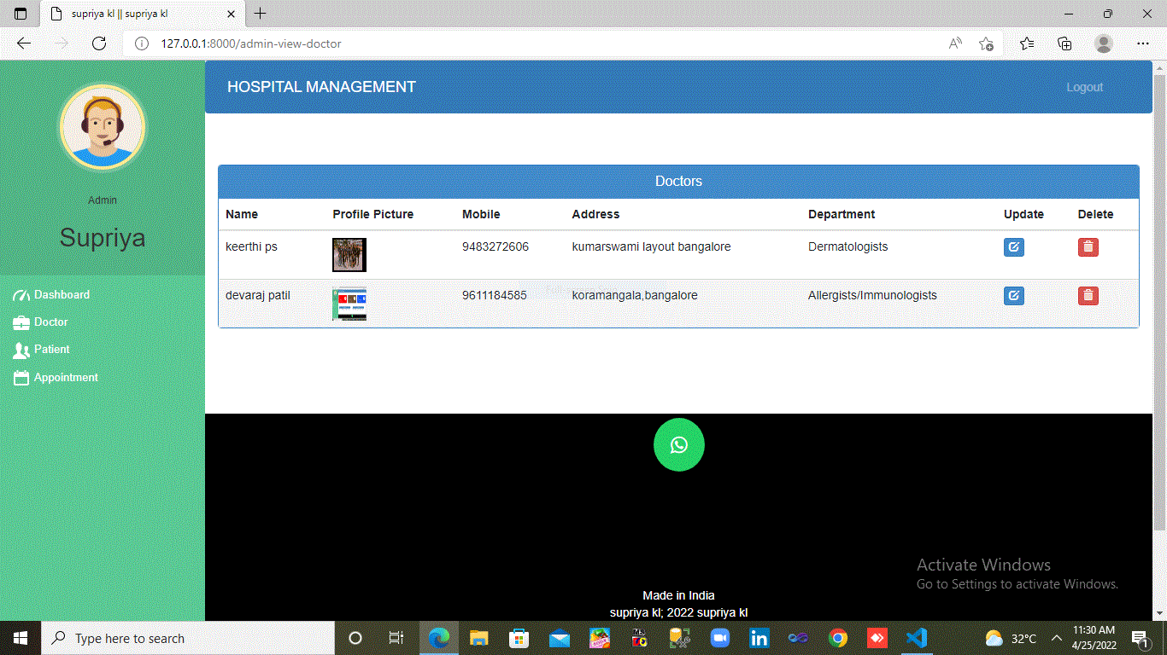

**Patient list:**

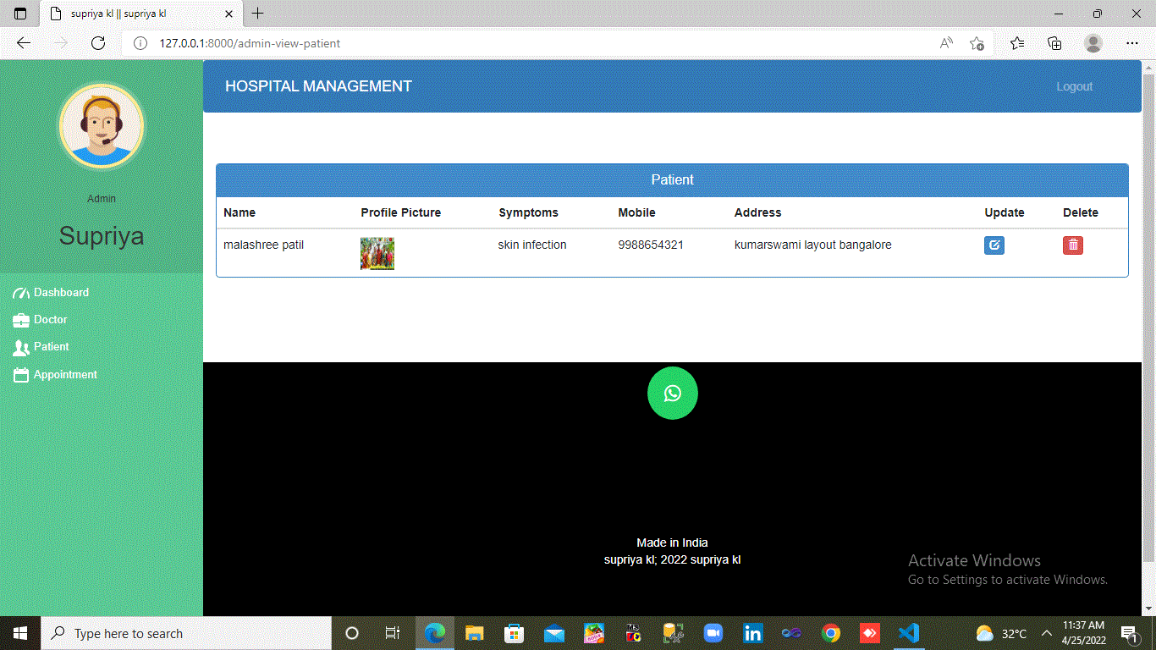

**Thank you**